**A.T.V.V. MANDAL’S**

**B. D. KALE MAHAVIDYALAYA,**

**Ghodegaon, Tal-Ambegaon, Dist-Pune.**

**PROJECT REPORT ON**

**ONLINE CAFÉ ORDERING SYSTEM**

**SUBMITTED BY**

**MISS. PRANALI BALASAHEB BHOR**

**MISS. PRACHI SAMPAT JOSHI**

**GUIDED BY**

**Prof. SWAPNIL DOKE**

**Prof. DNYANESHWAR LOKHANDE**

**FOR THE PARTIAL FULFILLMENT**

**OF**

**B.C.A. COURSE**

**OF**

**UNIVERSITY OF PUNE**

**FOR THE ACADEMIC**

**YEAR 2021-2022.**

**A.T.V.V. Mandal’s**

**B. D. KALE MAHAVIDYALAYA,** **GHODEGAON**



**B.B.A(C. A) DEPARTMENT**

**Certificate**

This is to certify that Project entitled **ONLINE CAFÉ ORDERING SYSTEM** Was completed by MISS. PRANALI BALASAHEB BHOR & MISS. PRACHI SAMPAT JOSHI As a requirement of S.Y.B.C.A (Semester IV) Examination for the academic year 2021-2022 for university of Pune.

Internal Examiner External Examiner

Coordinator Principal

Date:-

**CONTENTS**

* **Acknowledgement**
* **Introduction**

**2.1** Introduction to system

**2.2** Scope of system

**2.3** Proposed of system

* **System analysis**

**3.1** Fact Finding Techniques

**3.2** Feasibility study

**3.3** Hardware & Software Requirement

* **System Design**

**4.1** Entity Relationship Diagram

**4.2** Context Level Diagram

**4.3** First Level DFD

* **Form Design (with input values)**
* **Reports**
* **Advantages & Disadvantages**
* **Future Enhancement**
* **Bibliography**

**ACKNOWLEDGEMENT**

We are the student of **S.Y.B.C.A** division, very glad to present this **Visual Basic** project on“**ONLINE CAFÉ ORDERING SYSTEM**” to university of Pune.

Our project would have been incomplete without help pf out computer teacher.

We are very grateful to SIR MR. SWAPNIL DOKE & MR. DNYANESHWAR LOKHANDE for theirexcellent guidance and encouragement, without which the successful completion of this project would not have been possible. We are also very much thank full for their valuable suggestion and the supportive role played by them in the entire undertaking.

It gives me great pleasure to acknowledge the assistance of the college

Staff and our friends who through their kindness and thoughtfulness have helped me throughout. We are deeply owned to our family members for morally boosting us.

**Yours Sincerely,**

**MISS. PRANALI BALASAHEB BHOR**

**MISS. PRACHI SAMPAT JOSHI**

***INTRODUCTION***

***Introduction on to System :-***

Computers have become part of the life for accessing almost any kind of information. Life in the 21st century is full of technological advancement and in this technological age it is very difficult for any organization to survive without utilizing technology. The World Wide Web contributes greatly to the creation of an ever-increasing global information database. It could also be used as a mechanism to share information within an enterprise.

In today’s age of fast food and take-out, many cafe’s have chosen to focus on quick preparation and speedy delivery of orders rather than offering a rich dining experience. Until very recently, all of these delivery orders were placed over the phone, but there are many disadvantages to this system, including the inconvenience of the customer needing to have a physical copy of the menu, lack of a visual confirmation that the order was placed correctly, and the necessity for the cafe to have an employee answering the phone and taking orders.

What I propose is an online ordering system, which is a technique of ordering foods online applicable in any food delivery industry. The main advantage of my system is that it greatly simplifies the ordering process for both the customer and the cafe’s. When the customer visits the ordering webpage, they are presented with an interactive and up-to-date menu, complete with all available options and dynamically adjusting prices based on the selected options. After making a selection, the item is then added to their order, which the customer can review the details of at any time before checking out. This provides instant visual confirmation of what was selected and ensures that items in the order are, in fact, what was intended.

***Scope Of System :-***

The Online Cafe Ordering system is totally menu driven and uses clearly formatted screen displays to enter and process data generates reports.

All the rules and requirements of the ordering system taken into consideration.

while developing this system. The scope of the system as follows: Provide useful coding structure as per category with proper Recognition. Maintaining various master tables like Manager, Customers, items etc.

♠ Providing different types of reports:

a. Customers Personal report

b. Items report

c. Manager report

d. Customers Bill report

When the system starts it gives current status of data.

***Proposed System :-***

• This system is a bunch of benefits from various point of views. As this online application enables the end users to register to the system online, select the food items of their choice from the menu list, and order food online.

• Also the payment can be made through online mode or at the time of home delivery depending upon the customer’s choice and convenience. The selection made by the customers will be available to the hotel reception or to the person handling work assignment.

• Now this same person will assign the orders to the specialist chef to be completed within a fixed duration of time.

• As soon as the chef prepares the food, the later person forwards the parcels to the delivery persons assigned with the location and customer identity of the customer along with the bill status.

• With this application the work load of the waiter in the Cafe’s are reduced or in some situations the work is abolished.

• One of the various benefits of this is system is that if there is rush or a huge crowd present in the cafe then in that case sometimes unavailability of tables cut downs the cafe customer.

• Also there will be chances that the waiters are unavailable as they are busy in handling others, so the customer can directly order the food to the chef online by using this application, by checking the seat availability in the Cafe.

***System Analysis***

* ***Facts Finding Techniques:-***
* Various fact finding techniques were used to collect detail
* Information about each every aspect of the cafe ordering system. In order to gather.
* And analysis the relevant information the following fact finding techniques were adopted.

1. **On site Observation:-**

The first hand information about various activities that are carried out can be studied through observation of general procedures regarding maintaining the data about Café Management.

The information about cafe ordering system is stores in database.

As analyst this technique showed us many missed Facts. We also found some new ways to improve existing manual procedure.

1. **Record Review and Document searching:-**

A study of records maintained manually gave a clear idea as to how the actual process is carried out various documents which are handled their usage, formats were studied.

1. **Interviews:-**

Timely discussions with concerned person were made to understand the exact requirements of the system. These discussions were also useful in bringing up new ideas as to make system more effective. This technique is used to collect information from individuals or from groups. Through such invaluable techniques, it is possible to find much of the quality information and also some options and underlying problems

***Feasibility Study***

Feasibility Study is one of the most important & preliminary aspects of software development. We hereby specify three basic criteria of our feasibility study.

* ***TECHNICAL FEASIBILITY:-***

The study of resources availability that may affect the ability to achieve to acceptable system. The technical feasibility is frequently the most difficult area to assure because objectives, functions, and performance somewhat anything seems possible with technical feasibility includes resources availability of the origination for which the project is developed.

The system is developed using MS-Access, Visual Basic and it is found that the hardware and software in the company could easily support the hardware and software requirements of the system. The system can produce output on the Ink Jet Printer or other printer supporting normal 80-size text printing, hence no special printing device is required. The system being user friendly, data entry and report generation is made easy.

* ***ECONOMICAL FEASIBILITY:-***

The expanse of the hardware and software requirements of this system is found to be very cost effective and beneficial to the origination. The cost benefit analysis of the system was found to be pro benefit from the following points-

The technical facilities used in the system reduce the cost.

**1**. No Specific training is required to the user because the system is user friendly.

**2**. As all the system is computerized the cost of paper work and extra manpower is reduced.

* ***OPERATIONAL FEASIBILITY:-***

Consideration about the working after installation in the above feasibility analysis has already developed.

1. It helps to prepare clearly understandable and faster reports for management.
2. With appropriate error messages for every screen this makes the system easy for extreme user and very easy to operate any person.

* ***SOFTWARE & HARDWARE REQUIRNMENTS:-***

***❑ Software Requirement:-***

* **Front End : HTML , CSS , Javascript.**
* **Operating System : Windows 10 , 64-bit operating system.**

***❑ Hardware Requirement:-***

* **Processor : Intel(R) Core(TM) i3-1005G1 CPU @ 1.20GHz 1.19 GHz(x64-based processor)**
* **Memory : RAM - 8GB**
* **Storage Device : Hard Disk –1TB**

***System Design***

* ***Entity Relationship Diagram :-***

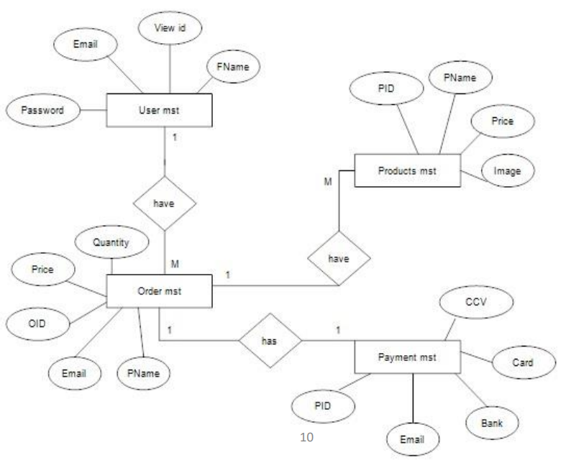

* ***Context level Data Flow Diagram :-***

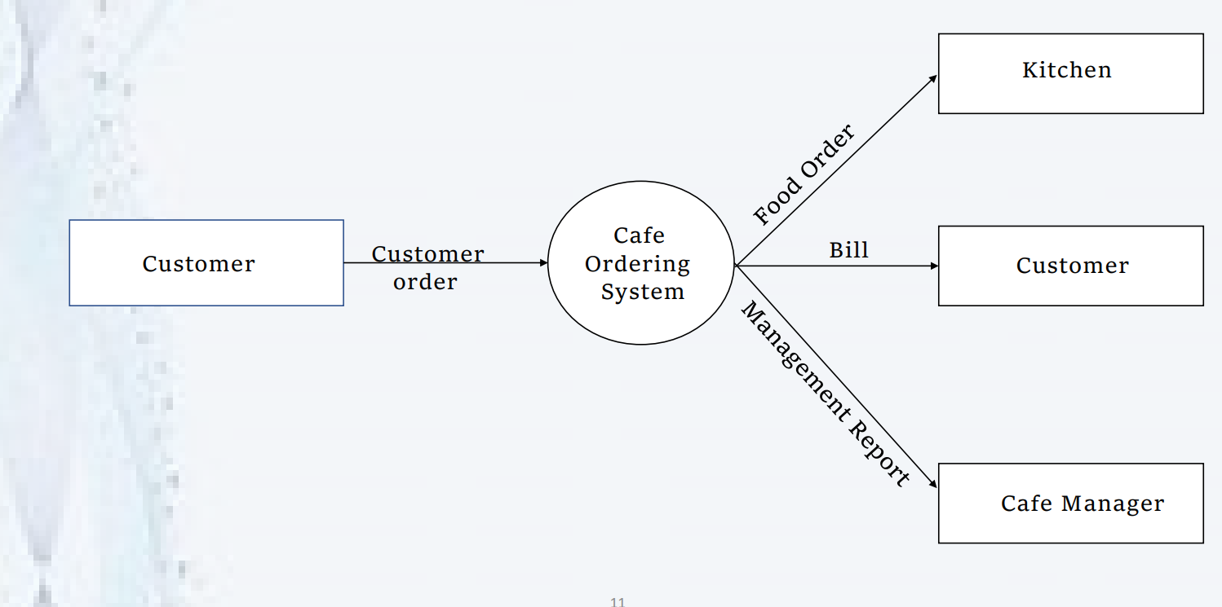

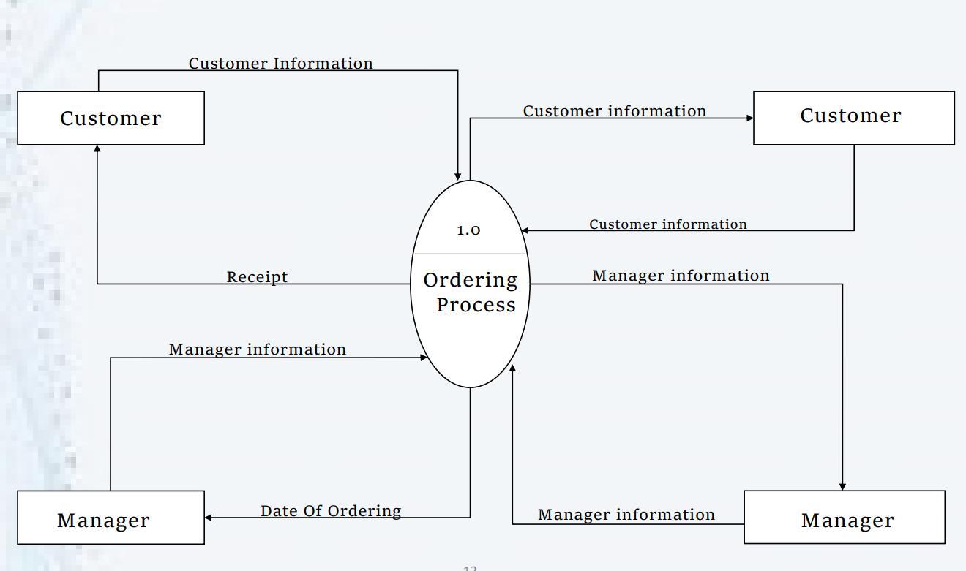

***Form Design***

**HOME PAGE**

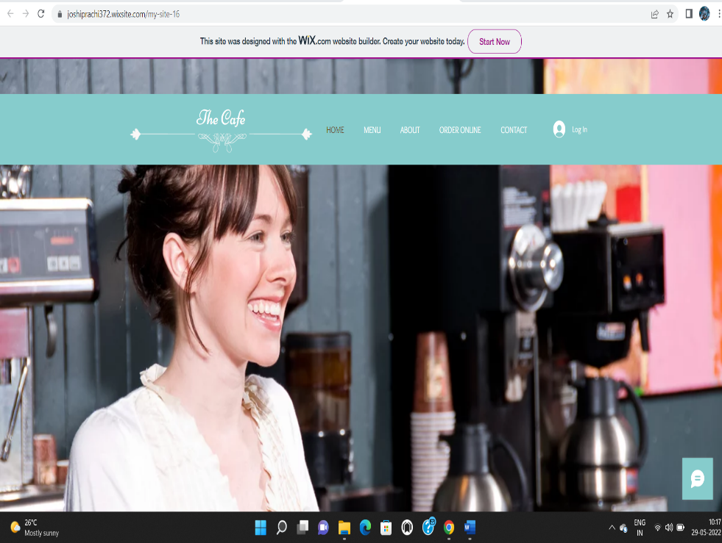

**MENU**

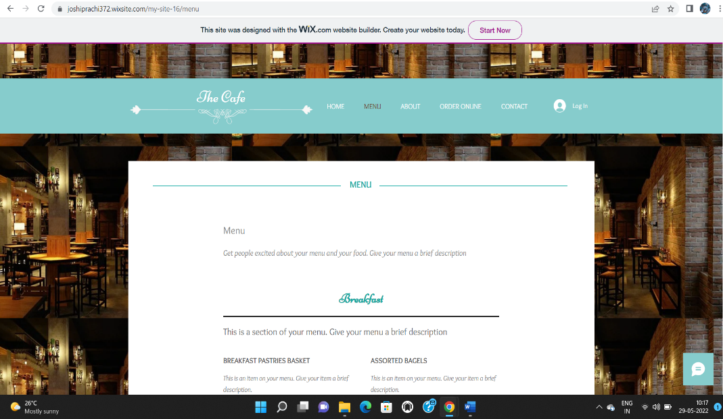

**ABOUT**

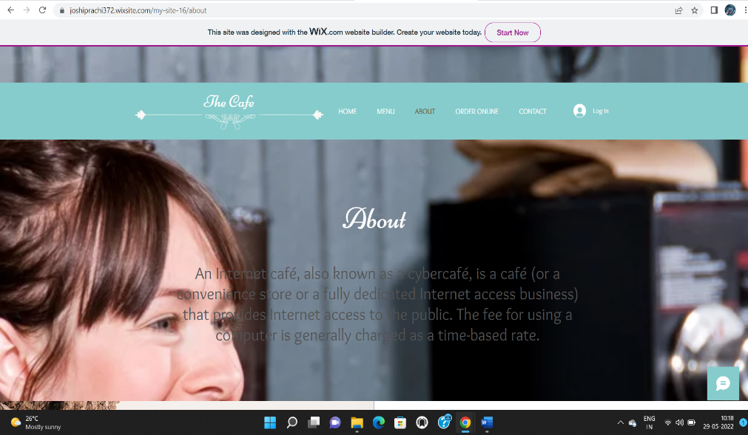

**ONLINE ORDER**

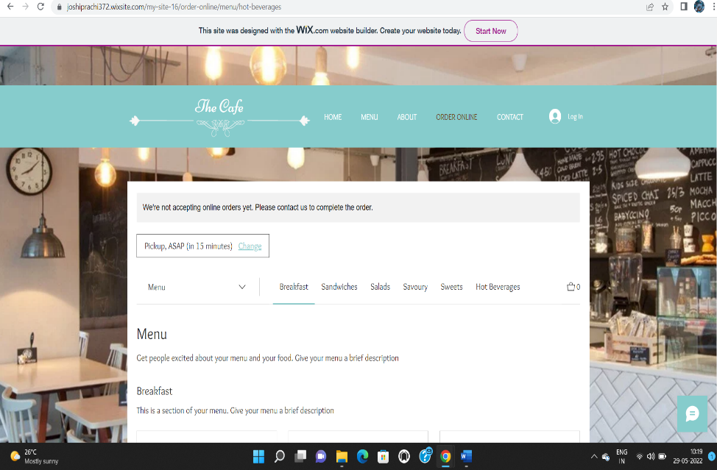

**CONTACT**

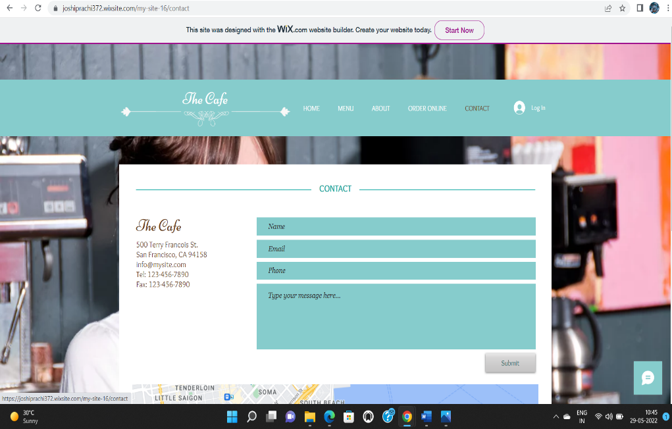

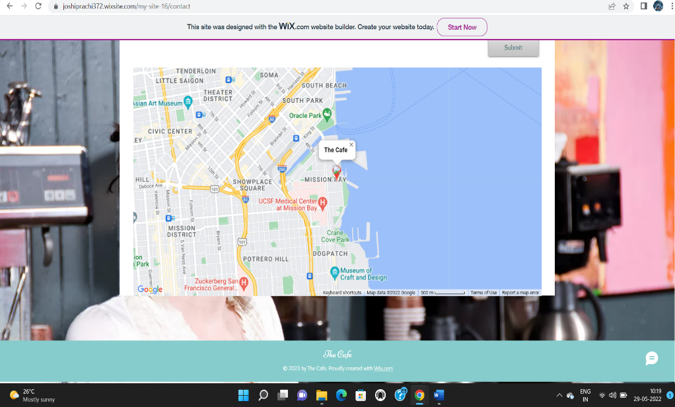

***❑ Advantages of the system :-***

❖ Makes managing order simpler.

❖ Manages entire business at one platform.

❖ Complete analysis of your business.

❖ Increase sales and revenue.

❖ Improves productivity.

❖ Keep track orders and deliveries.

❖ Daily and monthly revenue reports.

***❑ Disadvantages of the system :-***

❖ Data security.

❖ Risk of losing customers data.

❖ Chances of technical problem in the system.

❖ Mismatch data of orders, customers and drivers.

❖ Lack of good management of time and work.

***Future Enhancement***

❖ The possible enhancement are:-

❖ The system can be extended to include further activities like performance tracking of customer

❖ The organization has various other related applications built to automate its various tasks. All these process can be merged into a single complete cafe food ordering tool.

❖ The system does not currently have a “help” module since the targeted users are fully aware of the hiring process.

❖ This is include in the ordering system.

***Bibliography***

▪ www.w3schools.com

▪ [www.google.com](http://www.google.com)

▪ [www.youtube.com](http://www.youtube.com)